CALL WAITING SCENARIOS

# **Extension to Extension**

1. **When an extension is set on two devices**
   1. **Settings - Find Me Follow Me:**

1.1.1 Scenario 1 -When "Don't Ring" is set:

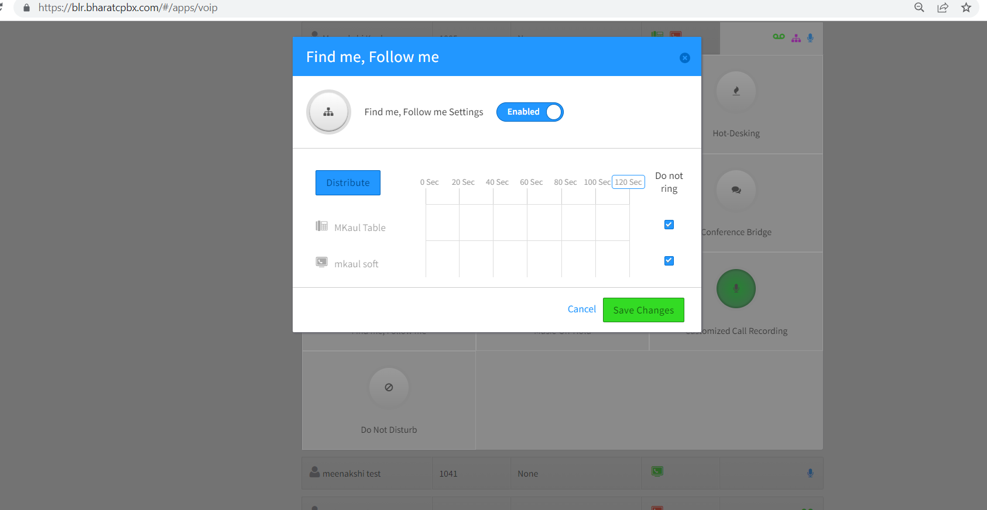

* **When calls are picked up from DT App**

1. When a call is made to 1005 for the first time, it rings on both the DT App and the Grandstream.

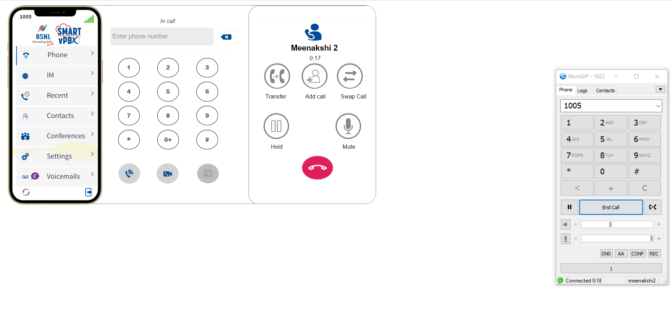

1. If the call is declined on the DT App, it continues ringing on the Grandstream.
2. When already on a call through the DT App and receiving a second call, the DT App shows "Call Waiting" while the Grandstream rings.

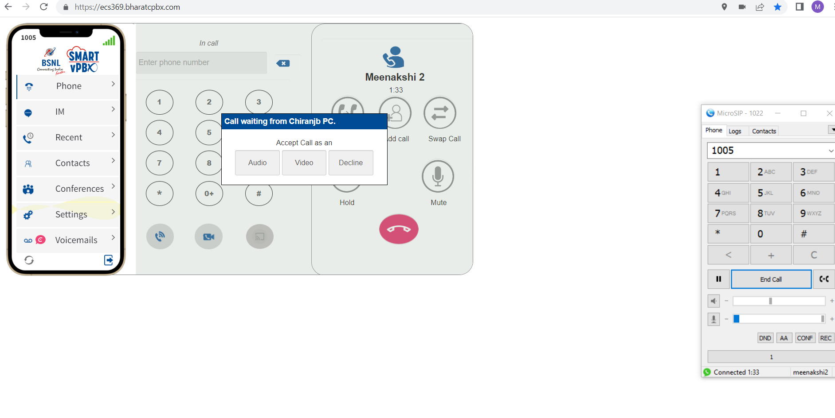

* **When calls are picked up from GrandStream**

1. When I pick the first call on the Grandstream, the call sometimes also connects on the DT App simultaneously. However, in most scenarios, the call on the DT App gets cancelled.
2. If I receive another call on the same extension while already on a call using the Grandstream, the new call will only ring on the Grandstream and not on the DT App.
3. A video demonstrating this behaviour has been attached to the email. (ExtensionVideo1- In video on Dt App, the call is coming as incoming and not call waiting.)

1.1.2 Scenario 2 - Find Me Follow Me set with a delay:

With a 20-second delay set for Grandstream and DT App:

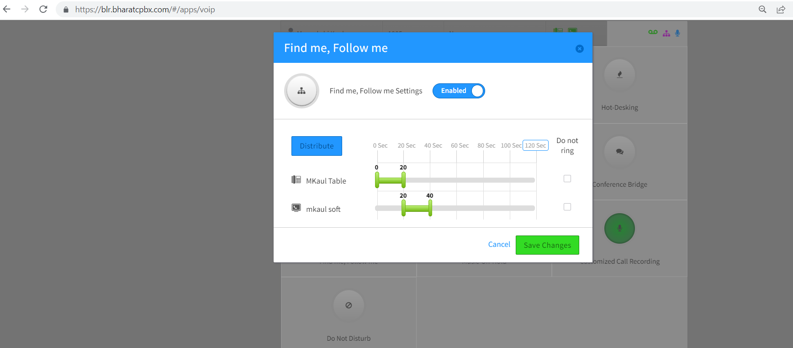

**A: When calls are picked up from DT App**

1. When a call is made to 1005, the Grandstream rings for 20 seconds, and then the DT App starts ringing.



1. If the call is accepted on the DT App, making another call to 1005 results in the Grandstream ringing first for 20 seconds and then the DT App showing "Call Waiting."



**B: When calls are picked up from GrandStream**

1. When I pick the first call on the Grandstream, the call on the DT App gets cancelled.
2. If I receive another call on the same extension while already on a call using the Grandstream, the new call will ring on the Grandstream and on the DT App Both.
3. A video demonstrating this behaviour has been attached to the email. –(ExtensionVideo2)

1.2.3 Scenario 3 - Overlapping Find Me Follow Me:

**A: When calls are picked up from DT App**

1. Calls come to both the Grandstream and DT App simultaneously.
2. It continues ringing until the call is picked up on the DT App or Granstream.
3. While on a call with the DT App, receiving another call results in both the DT App showing "Call Waiting" and the Grandstream ringing.

**B: When calls are picked up from GrandStream**

1. When I pick the first call on the Grandstream, the call on the DT App gets cancelled.
2. If I receive another call on the same extension while already on a call using the Grandstream, the new call will ring on the Grandstream and on the DT App Both.
3. A video demonstrating this behavior has been attached to the email. (ExtensionVideo3)
4. **When an extension is set on one device only(1041-SoftPhone)**
   1. **Settings - Find Me Follow Me:**
      1. Scenario 1 -When "Don't Ring" is set:

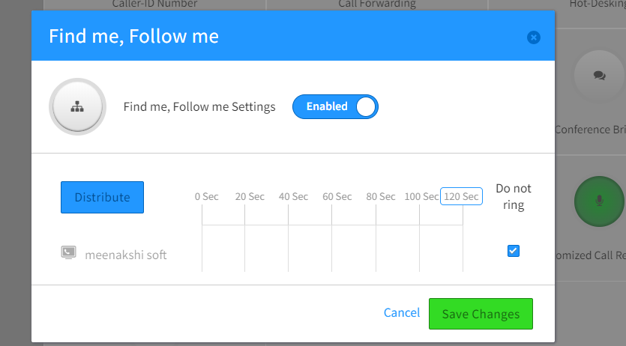

1.Keeps on ringing and then says endpoint not available after some time.

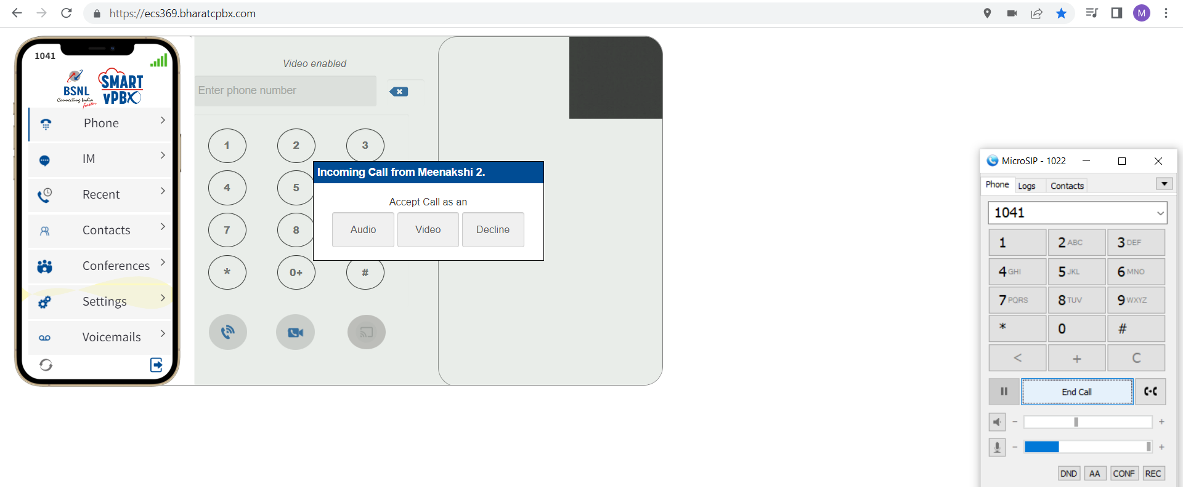

2.When another call comes then it shows call waiting popup on DT App

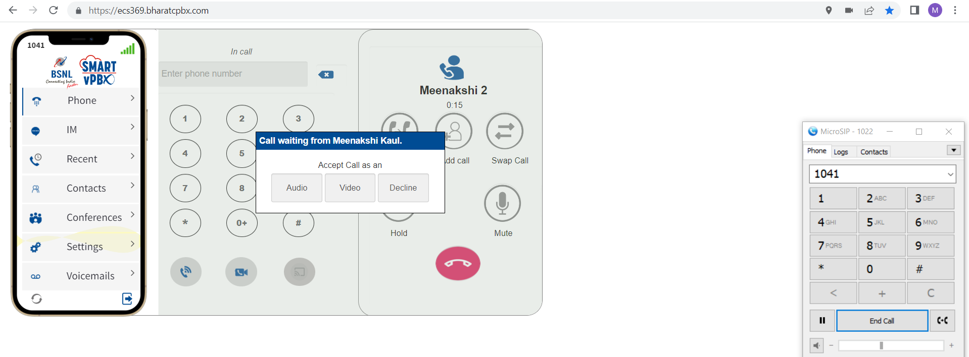

* + 1. Scenario 2 - Find Me Follow Me set with a delay: (Same as scenario 2.1.1)

|  |  |
| --- | --- |
|  | 1.Rings for 20 Seconds and then call ends  2.When another call comes then it shows call waiting popup on DT App |

1. **When an extension is set on one device only(1005-SipPhone)**
   1. **Settings - Find Me Follow Me:**
      1. Scenario 1 -When "Don't Ring" is set:



1.When a call is made to Sip Phone (1005), it rings as expected.

2.Accepting the call: Upon accepting the call, the connection is successfully established, and the call is answered.

3.Second call not coming through: However, when the Sip Phone is engaged in the first call, the second call does not come through to the Sip Phone. Instead, to the caller, it says, "Person Not Available" (i.e., Extension 1005 is not available).

3.1.1Scenario 2 - Find Me Follow Me set with a delay: (Same as scenario 3.1.1)

|  |  |
| --- | --- |
|  | 1.Rings for 20 Seconds and then call comes.  2.when the Sip Phone is engaged in the first call, the second call does not come through to the Sip Phone. Instead, to the caller, it says, "Person Not Available" (i.e., Extension 1005 is not available). |

Then I Enabled call waiting on Sip Phone (1005) to check if the second call comes. I Tested both scenarios again, but the issue persists, On second call it says person not available.

# **Calling from Mobile Phone on Extension**

1. **When an extension is set on two devices**
   1. **Settings - Find Me Follow Me:**

1.1.1 Scenario 1 -When "Don't Ring" is set:



* **When calls are picked up from DT App**

1. When a call is made to 1005 for the first time, it rings on both the DT App and the Grandstream.
2. If the call is declined on the DT App, it continues ringing on the Grandstream.
3. When already on a call through the DT App and receiving a second call, the DT App shows "Call Waiting" while the Grandstream rings.

* **When calls are picked up from GrandStream**

1.When I pick the first call on the Grandstream, the call on the DT App gets cancelled.

2. If I receive another call on the same extension while already on a call using the Grandstream, the new call will only ring on the Grandstream and not on the DT App.

1.1.2 Scenario 2 - Find Me Follow Me set with a delay:

With a 20-second delay set for Grandstream and DT App:



**A: When calls are picked up from DT App**

1. When a call is made to 1005, the Grandstream rings for 20 seconds, and then the DT App starts ringing.
2. If the call is accepted on the DT App, making another call to 1005 results in the Grandstream ringing first for 20 seconds and then the DT App showing "Call Waiting."

**B: When calls are picked up from GrandStream**

1. When I pick the first call on the Grandstream, the call on the DT App gets cancelled.
2. If I receive another call on the same extension while already on a call using the Grandstream, the new call will ring on the Grandstream and on the DT App Both.
3. A video demonstrating this behaviour has been attached to the email. –(ExtensionVideo2)

1.2.3 Scenario 3 - Overlapping Find Me Follow Me:

**A: When calls are picked up from DT App**

1. Calls come to both the Grandstream and DT App simultaneously.
2. It continues ringing until the call is picked up on the DT App or Granstream.
3. While on a call with the DT App, receiving another call results in both the DT App showing "Call Waiting" and the Grandstream ringing.

**B: When calls are picked up from GrandStream**

1. When I pick the first call on the Grandstream, the call on the DT App gets cancelled.
2. If I receive another call on the same extension while already on a call using the Grandstream, the new call will ring on the Grandstream and on the DT App Both.
3. A video demonstrating this behavior has been attached to the email. (ExtensionVideo3)

**2). When an extension is set on one device only(1041-SoftPhone)**

* 1. **Settings - Find Me Follow Me:**
     1. Scenario 1 -When "Don't Ring" is set:



1.Keeps on ringing and then says endpoint not available after some time.

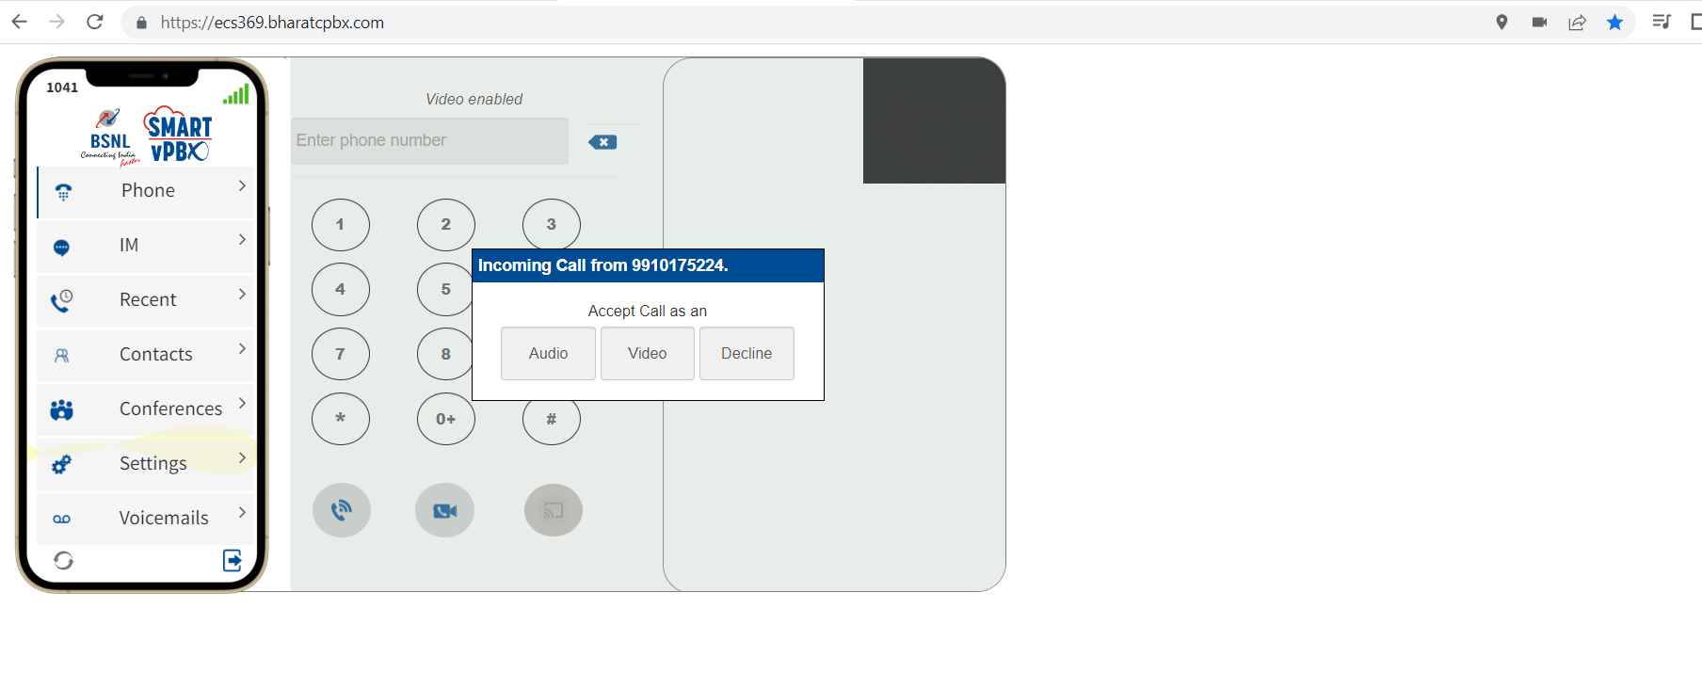

2.When another call comes then it shows call waiting popup on DT App

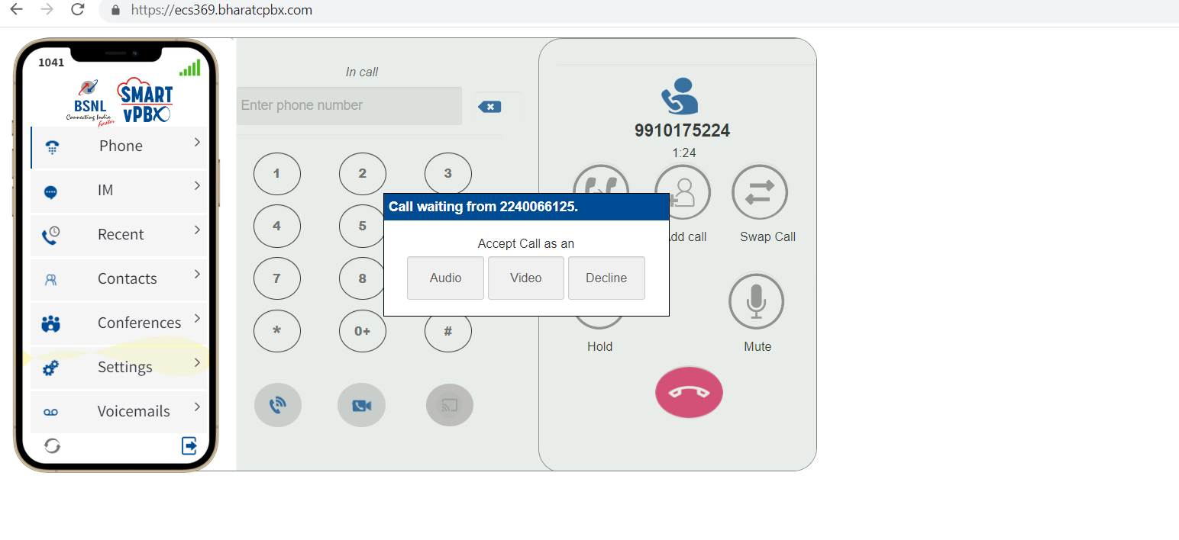

* + 1. Scenario 2 - Find Me Follow Me set with a delay: (Same as scenario 2.1.1)

|  |  |
| --- | --- |
|  | 1.Rings for 20 Seconds and then call ends  2.When another call comes then it shows call waiting popup on DT App |

**3)When an extension is set on one device only(1005-SipPhone)**

* 1. **Settings - Find Me Follow Me:**
     1. Scenario 1 -When "Don't Ring" is set:



1.When a call is made to Sip Phone (1005), it rings as expected.

2.Accepting the call: Upon accepting the call, the connection is successfully established, and the call is answered.

3.Second call not coming through: However, when the Sip Phone is engaged in the first call, the second call does not come through to the Sip Phone. Instead, to the caller, it says, "Person Not Available" (i.e., Extension 1005 is not available).

3.1.2 Scenario 2 - Find Me Follow Me set with a delay: (Same as scenario 3.1.1)

|  |  |
| --- | --- |
|  | 1.Rings for 20 Seconds and then call comes.  2.when the Sip Phone is engaged in the first call, the second call does not come through to the Sip Phone. Instead, to the caller, it says, "Person Not Available" (i.e., Extension 1005 is not available). |

Then I Enabled call waiting on Sip Phone (1005) to check if the second call comes. I Tested both scenarios again, but the issue persists, On second call it says person not available.